# Producing data visualisation II

#### Introduction

Visualisation is a process of intellectually constructing, shaping, and understanding information and communicating it externally. Technology has also improved visual presentation in the ability to quickly create complex visual information while easily distributing it through digital means.

There are numerous benefits to quickly and effectively communicating scientific information; however, researchers often lack the knowledge of design principles or technical skills to create specific visuals. Fortunately, numerous principles enable decision-making and informed choice-evaluation.

#### Activity: Choosing the best fitted visual display for given data

Analyse the data set below and draw a double bar graph and a double line graph on a sheet of paper to display the data. Once done, answer the two given questions.

|  |  |  |  |  |  |  |  |  |  |  |
| --- | --- | --- | --- | --- | --- | --- | --- | --- | --- | --- |
| *City A* | | | | | | | | | | |
| **Month** | **Jan** | **Feb** | **Mar** | **Apr** | **May** | **Jun** | **Jul** | **Aug** | **Sep** |
| **Temperature (°C)** | 8 | 9 | 11 | 14 | 17 | 20 | 23 | 23 | 20 |

|  |  |  |  |  |  |  |  |  |  |  |
| --- | --- | --- | --- | --- | --- | --- | --- | --- | --- | --- |
| *City B* | | | | | | | | | | |
| **Month** | **Jan** | **Feb** | **Mar** | **Apr** | **May** | **Jun** | **Jul** | **Aug** | **Sep** |
| **Temperature (°C)** | 9 | 9 | 12 | 18 | 22 | 25 | 27 | 30 | 26 |

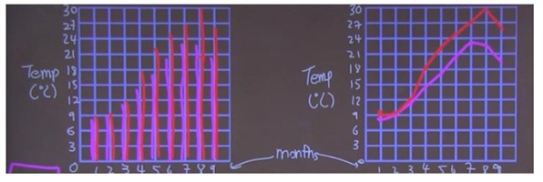

### 4.1.1 Reading charts and graphs

#### Tips to examine visual displays

Effective figure design communicates an understanding and interpretation of data, while ineffective design can mislead or confuse your audience. While a single best version of a given figure does not exist; there may be numerous good visual methods for presenting information, and it is the creators’ job to assess the pros and cons of each.

The following are a few tips to examine visual displays -

1. Purpose - Data visualisations are created with a purpose in mind: to be used as evidence to support an idea or claim
2. Axis - Identify information on each axis and the range covered by each axis
3. Patterns or Trends - Do you see any clusters, steady increases or decreases, consistent colouring?
4. Identify - Look for averages and/or exceptions and bold or highlighted data
5. Reading data - Data is typically read as [number of Ys per X].
6. Citations - Look for citations for the data to see where it originated and ensure it is credible.
7. Origin of data - Look for citations for the data to see where it originated and ensure it is credible.

* Who created the data?
* Is the creator an expert in this area?
* When was the data created?
* What geography does it cover?
* Is it objective data? Or is there some bias?
* Does the data make sense? Do you believe it?

1. Consider other factors - Consider other factors that may have shaped the data &, therefore, the visualisation. What factors not measured in the data set could have affected how the data is characterised?
2. Bias & Authority check - Consider the creator:

* Who did the primary research?
* What did the researcher try to figure out?
* How big was the sample size? Who was a part of the sample? How inclusive was it?

1. Reflect & Interpret - what is the takeaway of the visualisation based on patterns and other factors?
2. Infer further - what other information can you reason based on this interpretation?

#### Common visualisation mistakes:

The following are a few common visualisation mistakes

1. Truncated (shortened) Y axis - ‘broken scale’

Generally, the Y-Axis ranges from 0 to the maximum value that includes the range of the data provided. Sometimes, the range can be changed to emphasise variations in the data. But, if not limited, this technique can make differences look much larger than they are.

1. Misleading cumulative graphs

Beware of cumulative graphs. For example, instead of showing a quarterly profits graph, you could display a moving total of profits earned to date. In this case, critical variables may be excluded, oversimplified, or convoluted.

1. Ignoring conventions

Flouting standard practices of visualisations. You can misinterpret data if you ignore these conventions. For example, pie charts represent parts of the whole and timelines that progress from left to right.

1. Failed calculations

For example, pie charts should add up to 100%, and if not, the calculated response is wrong.

1. Visualisation type is incorrect

When the visualisation designer chooses a chart type based on appealing taste rather than the nature of their data.

1. Exhibiting too much data

This causes the visualisation to be too complicated for the audience to figure out.

1. Trying too hard to be original

Following the conventions is important for the audience's understanding. Arrange data naturally (alphabetically, sequentially, or by value) and in a reasonable way.

1. Making the reader work too hard

Some visualisations alone are insufficient and require the designer to add passing numbers, text, or trend lines.

#### Exemplary visuals and specific thought process and design choices

By knowing basic visual design principles and their execution, many figure creators may find new ways to emphasise and communicate their information.

How to approach the pursuit for visual information has been broken down into three tasks below:

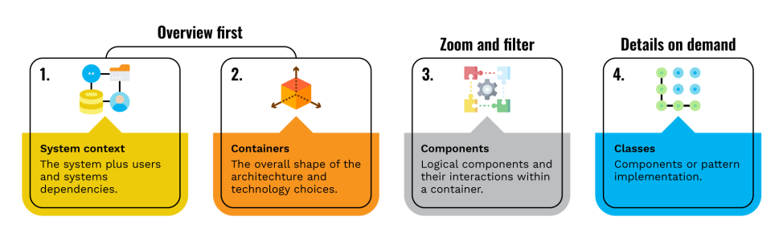

1. Overview first

This guarantees that the viewers have a general grasp of the data set as their starting point for study, offering them a visual glimpse of the distinct kinds of data, explaining their relationship in one glimpse. This strategy helps us visualise the data, at all its distinct levels, at one time.

1. Zoom and filter

The second step involves enhancing the first so that viewers understand the data’s core structure. The zoom in/zoom out process enables us to select noteworthy subsections of data that meet certain criteria while preserving the point of position and context.

1. Details on demand

The third step makes it possible to select a finer subset of data, facilitating the user to relate to the information and use filters by hovering or clicking on the data to get added information. These attributes are structure, position, form size, and colour, which can present information effectively when correctly used. The following chart summarises the main points to designing such a graphic, taking into account visual perception, allowing the users to assess the idea within the set of physical attributes.

The following principles are to be followed when making design choices:

1. Diagram first

Before creating a visual, order the information that is to be shared, imagine it, and design it. Critically focus on the information and design first before engaging a software that in some way limits or biases the visual tools. Think about the vital information that needs to be conveyed. For example, is your visual objective to show a comparison? A ranking? A composition?

1. Use the right software

Effective visuals require decent command of one or more software tools. It is unrealistic to design complex and technical graphs using a simple spreadsheet program or some other basic statistical software. It would help if you chose the software that will best represent your information before creating the visualisation.

1. Use a real geometry and show data

Geometries represent the data in different forms (like bars in bar plots), and there may often be more than one geometry to consider. The data-ink ratio principle should always be the basis of all your decisions. Most figures include amounts (or comparisons), compositions (or proportions), distributions, or relationships. For example, in the image below:

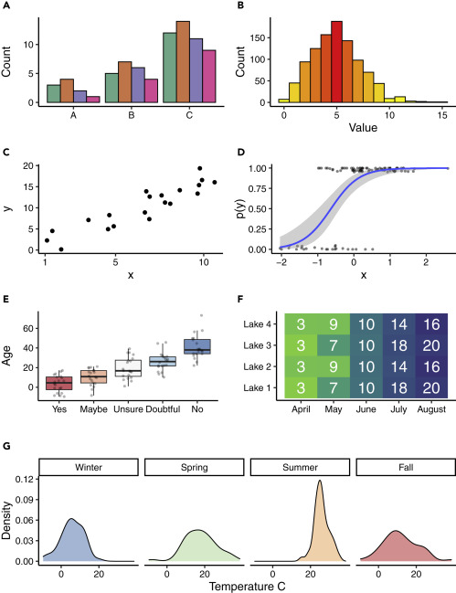

*Source: Examples of Visual Designs and Explanation (Midway, 2020)*

* Clustered bar plots effectively show units within a group (A–C) when the data are amounts.
* Histograms effectively show the distribution of data, which in this case is a random draw of values from a Poisson distribution and use a sequential colour scheme that emphasises the mean as red and values farther from the mean as yellow.
* Scatterplot where the black circles represent the data.
* Logistic regression where the blue line represents the fitted model, the grey shaded region represents the confidence interval for the fitted model, and the dark-grey dots represent the jittered data.
* Box plot showing (simulated) respondents' ages grouped by their answer to a question, with grey dots representing the raw data used in the box plot. The divergent colours emphasise the differences in values. Each box plot represents the interquartile range (IQR), the thick black line represents the median value, and the whiskers extend to 1.5 times the IQR. The data represent outliers.
* Heatmap of simulated visibility readings in four lakes over five months. The white numbers in the cells are the average visibility measures (in metres). The green colours represent lower visibility, and the blue colours represent greater visibility.
* The density plot of simulated temperatures by season is presented as a small multiple within the larger figure.

1. Significance of colours

There are two primary challenges when including uncertainty in visuals: failure to include uncertainty and misrepresentation (or misinterpretation) of uncertainty.

1. Include uncertainty

There are two primary challenges when including uncertainty in visuals: failure to include uncertainty and misrepresentation (or misinterpretation) of uncertainty.

1. Data and models are different things

Raw data and summarised data are often relatively straightforward but sometimes plotted models may require more explanation for the researcher to fully interpret before creating a visualisation.

1. Simple visuals, detailed captions

It's incredibly important to have detailed captions that fully explain aspects of the figure as is the data ink ratio. The principle remains that captions should well explain the visualisation and representations used. Captions should explain any geometries used.

1. Consider an infographic

Infographics were found to have the maximum memorability score and that diagrams outdid points, bars, lines, and tables in terms of effectiveness.

### 4.1.2 The pros and cons of different types of visualisations

#### Introduction

Graphs and charts are visual aids that allow you to deliver data and statistics to your audience during a presentation. Diverse types of graphs can be used to deliver the different information required. Every graph has its advantages and disadvantages, but they also have some common benefits. Let us explore some of the main graphs that are in use.

1. Pie chart or circle graph

A pie chart is a graph that features a circle cut into different segments or ‘pie slices,’ also called circle graphs. Each sector stands for the relative size of value for a whole, with proportionate sizing for the quantity it represents.

1. Advantages

* The graph can be compared to the quantity it needs to show and displays multiple classes of data in one chart.
* Puts large sums of data into visual form for easy understanding and offers easy calculations of data accuracy.
* More visually appealing than other graphs and requires little explanation.
* Understood easily by different departments within a business and for media purposes.

1. Disadvantages

* Does not reveal exact values, and multiple graphs are needed for time-series data.
* Key assumptions, causes, effects, and patterns stay hidden.
* Manipulated easily can cause false interpretations.

1. Bar graph or Pareto graph

A bar graph uses rectangles or narrow columns to show data comparisons like a pie chart. The height of the bar graph shaded in represents various measures. A Pareto graph or chart is a bar graph that also features a line graph.

1. Advantages

* Each data category is displayed in a frequency distribution pattern and relative numbers or proportions of multiple categories.
* Easy summarisation of large data sets and briefly offers estimated values of key factors.
* A clearer understanding of trends over table charts gives the ability to visually check the accuracy of calculations.
* Easy for the audience to understand and decipher the information presented.

1. Disadvantages

* An additional explanation is required and can be manipulated to show false results.
* Unable to display key assumptions or patterns in the data.

1. Histogram

A histogram is a plot or chart that allows you to show the underlying frequency distribution of a continuous set of variables. Unlike a bar graph, a histogram only displays a single variable.

1. Advantages

* Work well for displaying large ranges of data or information
* Intervals are always equal, allowing for consistency with data and Easy to transform data from frequency forms to graph forms

1. Disadvantages

* Impossible to obtain an exact amount for input and difficult to compare multiple points of data in one chart.

1. Stem and leaf Plots

Stem and leaf plots are charts that allow you to split data values into a ‘stem’ and ‘leaf’ pattern and show the frequency of the values that occur. This usually consists of putting the first value into the stem column and the last digits into the leaf column.

1. Advantages

* Provide simplified methods for keeping scores and can manage substantial amounts of data in an organised manner.
* Offers the ability to show ranges, minimums, and maximums for numbers instantaneously.

1. Disadvantages

* Not a visually appealing method for captivating an audience and appears messy with extensive data.
* Longer ranges and variances can be difficult to break down into useful data groupings.

1. Dot Plots

Dot plots are graphs used for displaying small sets of data and groups. These charts use dots to represent the frequency of data and are displayed in columns that correspond with certain categories.

1. Advantages

* Easy to create and does not need complicated software.
* Ability to show various categories in one graph.

1. Disadvantages

* Not visually appealing and works well with small sets of data.
* It can be difficult to read with enormous amounts of data.

1. Scatter plots

A scatterplot is a graph that uses a series of dots to represent two distinct values of information being compared. The position in which dots are placed along the horizontal and vertical lines represents that data point's value.

1. Advantages

* Can be used for demonstrating the connection of substantial amounts of data.
* Works for most types of data and provides an accurate flow of information being conveyed.

1. Disadvantages

* It can be difficult for everyone to follow.
* It can easily be manipulated to misrepresent data.

1. Time-series graph

A time-series graph is a chart that shows data recordings taken at regular time intervals. The time is shown on the horizontal access with waves that show the documented information. These graphs are often used to show trends and patterns for various categories.

1. Advantages

* Allows for the understanding of past performances and future predictions
* Offers comparisons of two subjects simultaneously and helps gauge the present performance more closely.

1. Disadvantages

* Not always accurate with findings and depiction.
* Factors being examined may not be the same for extended periods, causing the data/information to be unreliable. Factors causing fluctuation cannot be adjusted all the time.

The following videos are recommended to support your understanding.

1. Watch this 4-minute 9-second video to learn how to spot a misleading graph. [https://youtu.be/E91bGT9BjYk](https://youtu.be/E91bGT9BjYk" \o "Share link" \t "https://www.youtube.com/embed/_blank) *Source: ([TED-Ed](https://www.youtube.com/@TEDEd" \t "https://elearn.sunway.edu.my/webapps/blackboard/execute/_blank), 2017)*
2. Watch this video of 7-minute and 39-second to learn how to analyse and effectively communicate your data. [https://youtu.be/dQba301yk2A](https://youtu.be/dQba301yk2A" \t "https://www.youtube.com/embed/_blank) *Source: ([Growth Tribe](https://www.youtube.com/@GrowthTribe" \t "https://elearn.sunway.edu.my/webapps/blackboard/execute/_blank), 2019)*
3. Watch this 9-minute 12-second video to explore how to extract insights from data. <https://youtu.be/wFLbWR7jLFw?si=Uu6HymgdLDeQ2dZu> *Source: ([Raj Ramesh](https://www.youtube.com/@RajRamesh" \t "https://elearn.sunway.edu.my/webapps/blackboard/execute/_blank), 2018)*

### 4.1.3 Can you choose the appropriate graph?

#### Activity: Draw the most suitable graph for the given data

****Time****: 20 minutes

****Purpose****: To choose an appropriate graph

****Task****: The table below shows the humidity level, recorded in Small Town, NY for seven days. Construct a graph which best demonstrates the humidity level for each day and present your analysis. Submit your work in the form of a pdf document and add it to the discussion forum.

****Feedback****: You may use the forum to upload a pdf document complete with the graph and analysis. Subject Leader and Facilitator to review documents and provide feedback.

|  |  |  |
| --- | --- | --- |
| *Humidity Levels in Small Town, NY* | | |
| **Day** | **Humidity Level (%)** |
| 1 | 51 |
| 2 | 59 |
| 3 | 65 |
| 4 | 68 |
| 5 | 70 |
| 6 | 67 |
| 7 | 72 |

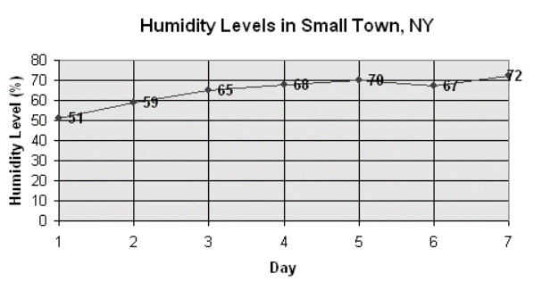Source: (Sunway University, 2022)

## 4.2 Ordering, emphasising, alignment and positioning

#### Introduction

Creating effective views requires effort, perception, diligence—and trial and error. Even after creating the best chart type for your analysis, effective views do not always occur spontaneously. Many chart types let you put numerous measures and dimensions in one view. Selecting where to put each measure depends on what kind of assessment you are doing and what you are trying to highlight.

#### Activity: Understanding ordering and positioning

****Time****: 10 minutes

****Purpose****: To understand ordering and position in data visualisation

****Task****: Reflect on the visualisations below and answer the given questions

****Feedback****: To help further the conversation, respond to the posts of at least 2 of your peers. You can ask them questions for clarification on their approach or provide them with feedback. Your facilitator will moderate this discussion.

##### **Questions**

1. The graph on the left shows the temperature preference of 20 test subjects. Ten prefer cold; six prefer hot; four prefer neither. We have a person's shape divided up to represent the three categories of responses. What does and does not work for this graph? Justify your answer.

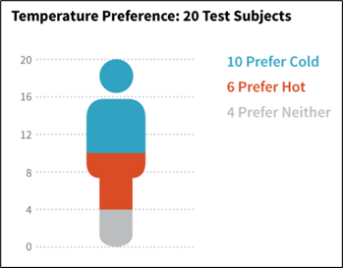

Source: Visualizing Data (PRB, 2018)

2. The chart shows ‘the cost of magical things’ in blue and red in the United States and the United Kingdom. The axis on the left is in dollars, and the right is in euros. What do you think is wrong here with the bar chart? Justify your answer.

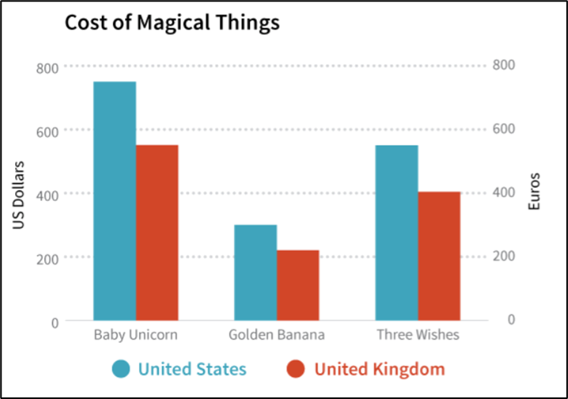

Source: Visualizing Data (PRB, 2018)

### 4.2.1 Ordering, emphasising and positioning

#### Type of graph and ordering of data within the visual

Data visualisation is part art and science, and the challenge is balancing both. A data visualisation must accurately convey the data without misleading or distorting it.

The following are two ways of organising data within a visual:

1. Organise your views

For instance, you want to evaluate a sales team by comparing their sales with their quotas. As concluded in the chart below, your perception might tell you to put the two measures close together or side-by-side. However, does the chart easily demonstrate how well Greg Powell has performed? The chart shows that he is above quota, but not by how much. With two side-by-side horizontal bars, it can be not easy to make comparisons like this. (Tableau.com, n.d.)

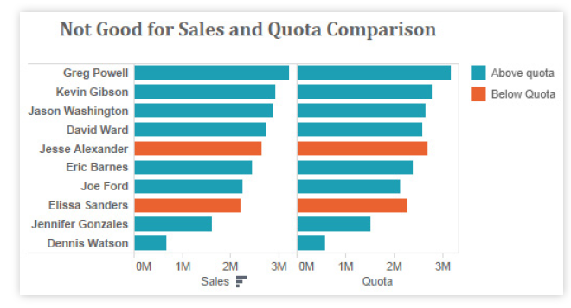

*Source: Visual Analysis Best Practices, Simple Techniques for Making Every Data Visualization Useful and Beautiful (Tableau.com, n.d.)*

However, as shown in the bullet chart below, instead of putting sales and quota data into columns, putting them into rows creates a shared baseline for the sales bar and the quota bar, making comparison far easier. It becomes evident that Greg Powell is above quota, but only by a small amount.

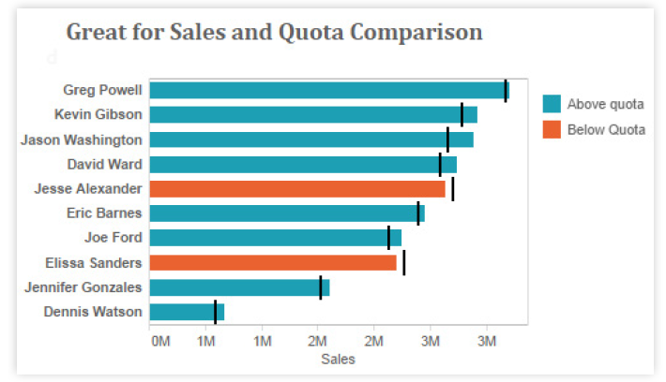

*Source: Visual Analysis Best Practices, Simple Techniques for Making Every Data Visualization Useful and Beautiful (Tableau.com, n.d.)*

In this instance, ‘actual’ is sales (bars) and ‘target’ is quota (vertical reference lines). Not only is it easy to see how well each salesperson is performing to their quota, but it is also possible to cut down 50% of the bars by displaying data in reference lines. (Tableau.com, n.d.)

A rule of thumb is to put the most important data on the X- or Y- axis and less important data on colour, size, or shape.

1. Avoid overloading your views

Overloading a view is one of the most common mistakes people make in data visualisation. Look at the chart below. Can you tell how well India is doing in sales and profits per customer and department?

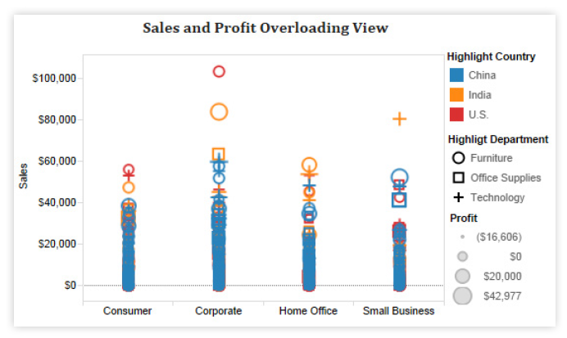

*Source: Visual Analysis Best Practices, Simple Techniques for Making Every Data Visualization Useful and Beautiful (Tableau.com, n.d.)*

There are too many measures and dimensions shown in this view. Instead of stacking countries, departments, and profits into one condensed view, breaking them down into small multiples will allow you to see and understand all the relevant information in seconds. The chart below is a notable example of where smart usage of visualisation in combination with traditional crosstabs can have clear advantages. (Tableau.com, n.d.)

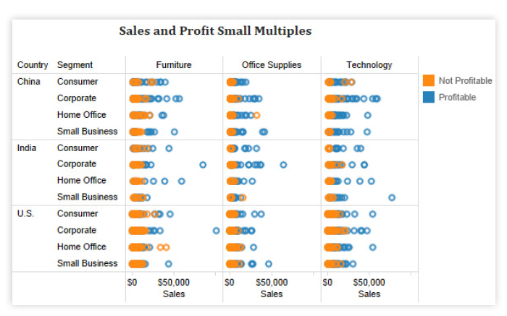

Source: Visual Analysis Best Practices, Simple Techniques for Making Every Data Visualization Useful and Beautiful (Tableau.com, n.d.)

#### Steps to emphasize and de-emphasize through the use of colours, the thickness of lines, and relative sizes

Below, you will see a view produced for homebuyers to help them understand the relationship between home price, home size, lot size, and the type of home they are interested in. What is the first relationship you see in this view?

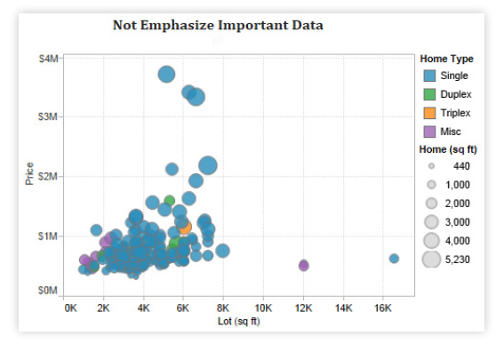

Source: Visual Analysis Best Practices, Simple Techniques for Making Every Data Visualization Useful and Beautiful (Tableau.com, n.d.)

Yes, the relationship between price and lot size is clear. But is this essential information for homebuyers? Not, the relationship between price and home size takes precedence. Finding a home with the right livable space for most homebuyers takes priority over the lot size. Therefore, the chart below is more effective. (Tableau.com, n.d.)

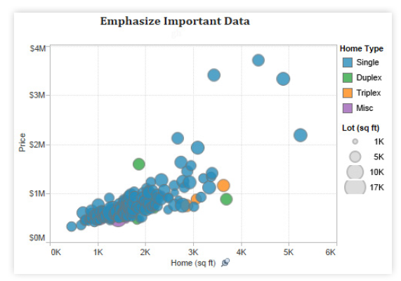

Source: Visual Analysis Best Practices, Simple Techniques for Making Every Data Visualization Useful and Beautiful (Tableau.com, n.d.)

Colour can make an impactful difference between a boring visualisation and an inspirational one. The following tips will help you create effective visualisations with colour:

1. Try to restrict your use of colour palettes to two and use non-overlapping scales like the ones shown below.

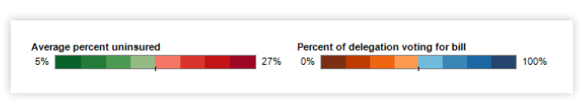

Source: Visual Analysis Best Practices, Simple Techniques for Making Every Data Visualization Useful and Beautiful (Tableau.com, n.d.)

1. Select semantically meaningful colours if they apply to the context of your data. If there are no relevant colours in the context of your data, use the Tableau colour sets; they have been carefully selected to match and not clash.
2. Once you have selected your colour palettes(s), consider whether any of the colours in it have alternate meanings that do not align with your message. When using colours with inherent meaning, ensure you have assigned them to important values in your database. For example, green is associated with positivity in many cultures, while red has a negative connotation. (Source: Tableau.com)
3. If the meaning behind your colour choice is not obvious, or your visualisation does not label the colour, make sure to include a legend.
4. The midpoint and endpoints should be meaningful when using a varying colour palette. Zero is often a meaningful midpoint.
5. Avoid adding colour encoding to more than 12 distinct values.

#### Alignment and positioning of components within the visuals and the effective use of words to title, label, and annotate

Sometimes, simple changes are key towards making your visualisations easy to relate with.

1. **Align your views for readability**

Observe the view below.

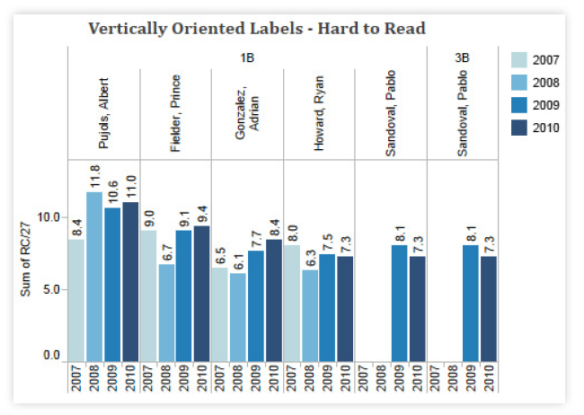

Source: Visual Analysis Best Practices, Simple Techniques for Making Every Data Visualization Useful and Beautiful (Tableau.com, n.d.)

This view is difficult to read because all the labels are vertically positioned. If you come across a view with long labels that only fit vertically, try turning the view. You can quickly swap the fields on the Rows and Columns shelves using the Swap toolbar. The same view is shown below—only this time with a horizontal orientation. This simple change makes the chart easier to read and make comparisons with.

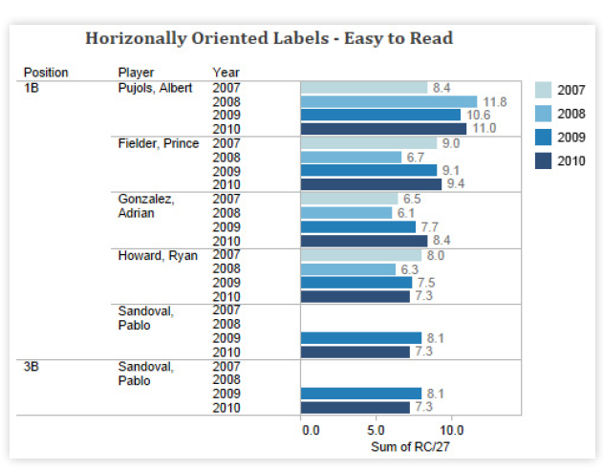

Source: Visual Analysis Best Practices, Simple Techniques for Making Every Data Visualization Useful and Beautiful (Tableau.com, n.d.)

1. **Labelling**

Labels (the labels on your data points) can help you tell your story quickly and neatly. It is often easier to read a marked label than to mouse over a data point for its tooltip. If several labels are close together, you may want to select a different option to avoid clutter. You can highlight important labels. Mark labels outliers by marking the minimum and maximum values in the view.

You may visit <https://visualgo.net/en> to explore data visualisation further through animation.

Watch this video from 20:35 to 34:45 to support your understanding of design principles. <https://youtu.be/ajhnJnLcev0> *Source: ([UN Innovation Network](https://www.youtube.com/@UNInnovationNetwork" \t "https://elearn.sunway.edu.my/webapps/blackboard/execute/_blank), 2021)*

### 4.2.2 Ordering and emphasising in Tableau

#### Activity: How to order and emphasise graphs in Tableau

****Time****: 30 minutes

****Purpose****: To learn how to emphasise and order graphs in Tableau

****Task****: You will work with a sample data set named Superstore dataset, which comes pre-loaded with Tableau. The data is that of a superstore. It contains information about products, sales, profits, etc. Your aim as Data Analysts is to analyse the data and find critical areas of improvement within this fictitious company. Refer to the document below and then answer the given questions in the discussion forum.

Q1. What does the line chart in the document convey?

Q2. What information can you infer from the created visualisation?

Q3. How can we identify which furniture item is contributing towards maximum sales?

Q4. Take a closer look at the filters to find out more about the unprofitable products. List your key findings.

## 4.3 Storyboarding and dashboards

#### Introduction

During data analysis, the user looks for proof from the data to build, verify or refute a claim. Based on the evidence’s relations with the data in the context of the analysis’ objective, the user’s mind creates mental models of the information structure.

#### Activity: Explore a dashboard

When designing a dashboard, it is important to structure it in a way that is available to your audience. For example, the dashboard below is a fitting example of interactive views that tell a single story together.

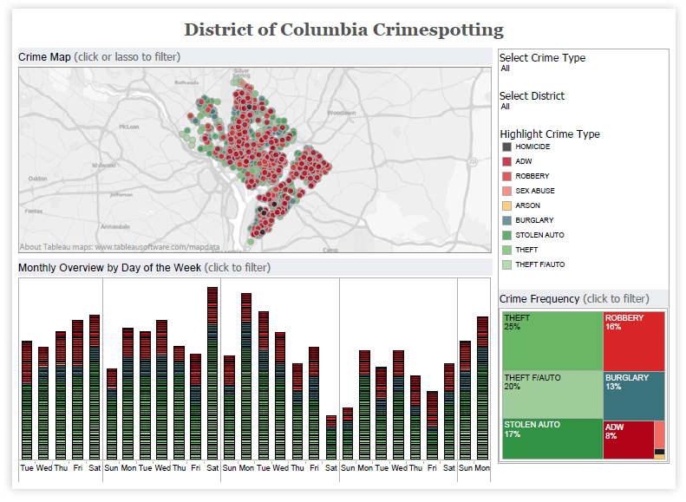

Source: District of Columbia Crimespotting (Public Tableau, 2018)

**Question**: What important piece of information is it trying to tell? Explain your answer.

Then, follow these [simple instructions](https://help.tableau.com/current/pro/desktop/en-us/dashboards_create.htm" \t "https://elearn.sunway.edu.my/webapps/blackboard/execute/_blank) ([https://help.tableau.com/current/pro/desktop/en-us/dashboards_create.htm](https://help.tableau.com/current/pro/desktop/en-us/dashboards_create.html)) to create your first Dashboard in Tableau. You can use a sheet you have previously created or create a new one with the given sample database 'Superstore Sales'.

#### Creating storyboards for dashboards

###### **Explore: All about storyboards**

Storyboards are visual representations of the content you plan to create. In data storytelling, the storyboarding process is a wonderful way to take the vital message and data elements out of long and complex reports and design them to tell your story.

Visualisations are built to help tell a story about the gathered information. This storyline draws the audience’s attention to significant patterns and key insights amid all the data bits.

1. On the first sheet of paper, write down the problem that inspires your data project. For example, when working on the sales reports, our problem statement was: You need to find out our manager’s backgrounds and interests about data visualisation, to write a better introductory guide that meets their needs.
2. Rewrite your problem statement on the second sheet of paper into a question. Write a question you honestly do not know the answer to—and punctuate it with a question mark.
3. On the third sheet of paper, draw pictures and arrows to show how to find data to answer your question above. Sketch a picture of your data compilation process to show how you plan to bring together various pieces of information.
4. On the fourth sheet of paper, sketch at least one type of visualisation you plan to create after acquiring your data above. Do you visualise charts like a bar, line, or scatter chart? Or do you imagine some map with points or polygons? If your visualisations are interactive, try to show the concept using buttons and more than one sheet of paper. You can add fictional data at this stage because it is an initial sketch.

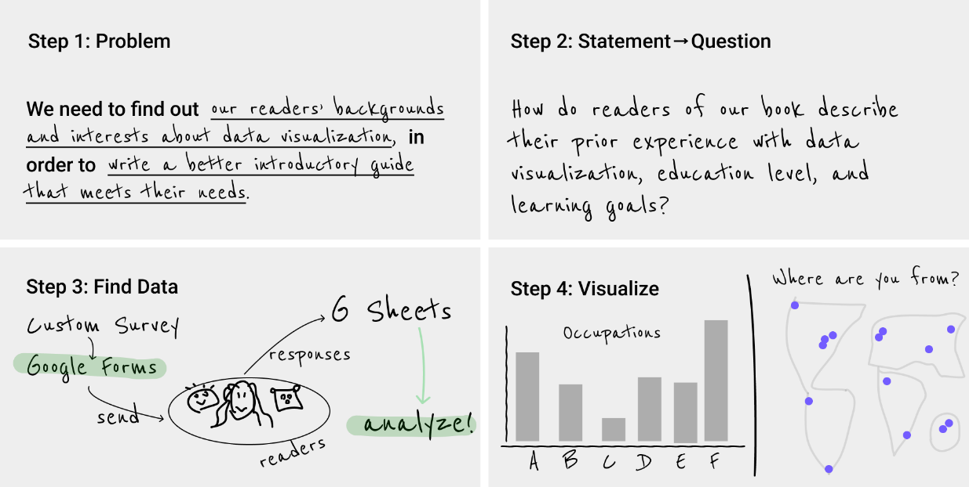

Source: Hands-on Data Visualization (Dougherty and Ilyankou, 2022)

1. Articulate what your eyes see as the most insightful finding for your most important visualisations. The next step is to summarise the most important message the data reveals and write it as a line summary at the top of each page that contains a table, chart, or map. One of the best ways to interpret charts or maps into words is to describe precisely what captures your eye as the designer and convey this to your reader, who sees it for the first time and relies on your guidance.
2. At the bottom of each visualisation, write why it matters, and build up to how audiences should rethink or react. An effective way to discuss the implication of your data story is to focus on how this current information varies for us.

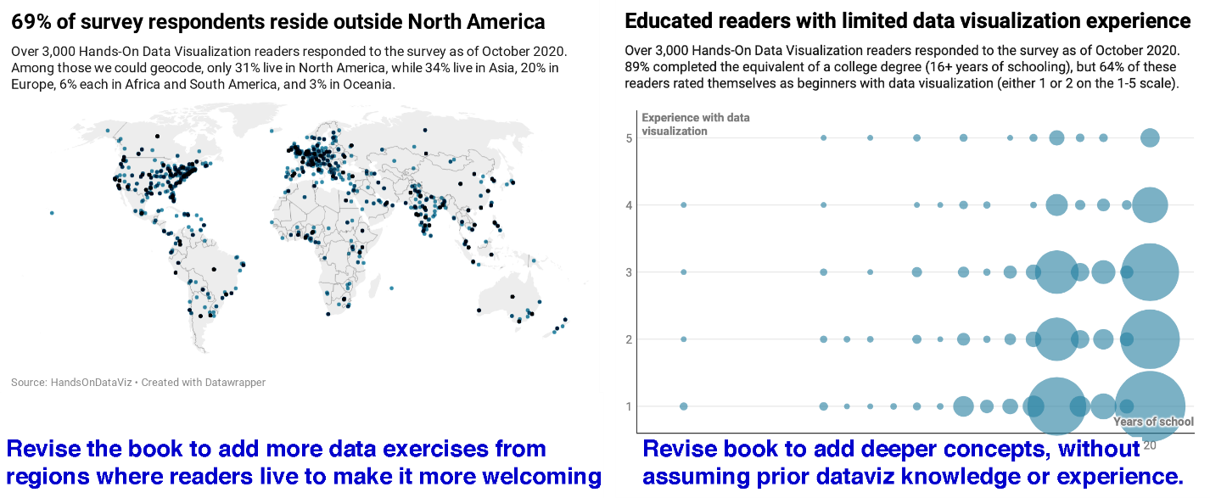

Source: Hands-on Data Visualization (Dougherty and Ilyankou, 2022)

1. As you complete your work, your layout might look something like this:

* problem statement
* research question
* how you found data
* indicate first data insight—show evidence—why it matters
* indicate second data insight—show evidence—why it matters
* your summary conclusion.

#### Examples of storyboards

The storyboarding process in four simple steps:

1. Outline

in the first step of the storyboard process, you must obtain the key data points - what do you want to tell your target audience?

1. Sketch it

use this step to list all the messages you predict are needed as raw material and sketch them in the squares of your storyboard. Ensure that you have gathered all the information and key points for your data story.

1. Arrange the storyboard

think about how this story will unfold, and are there any missing points, anything that you will not need?

1. Brainstorm visualisations

the last step is to think about visualising your data and trying different ideas.

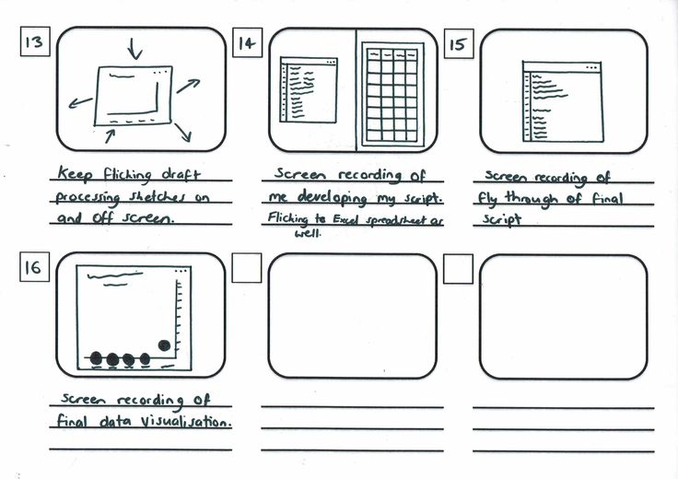

Source: Storyboard Part 3 (Adriana, n.d.)

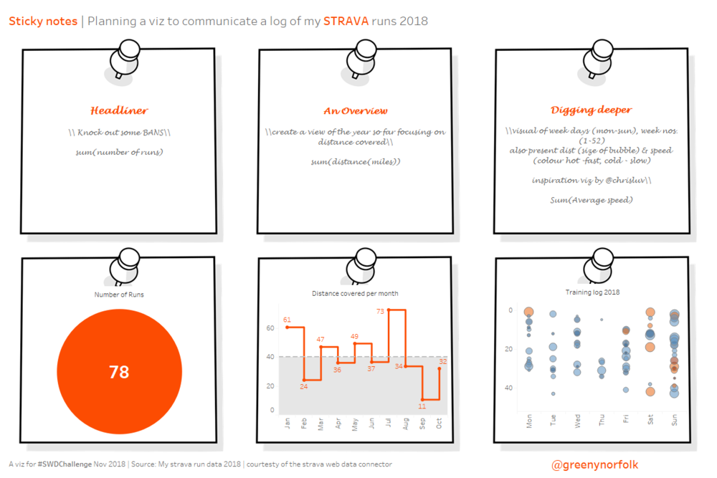

Source: stickies! (KNAFLIC, 2018)

#### Examples of dashboards

The dashboard planning process is called storyboarding. You judiciously design storyboards for the dashboards you hope to create and outline the process of creating a data visualisation storyboard. The process is as follows:

1. ****Making a catalogue of ideas****: This is the most crucial thing – you cannot figure out the right data to visualise until you have a story.
2. ****Looking for themes****: Are there any interesting relationships with your data you want to focus on?
3. ****Starting with the reports you have****: What would that report you run every day, week, or month show on a dashboard? This is a suitable place to start, and it will be easy to see how dashboards can help you save so much time.
4. ****Who is this dashboard for?**** Set up a meeting to focus groups so you can get a clearer idea of what they expect. That way, you can build a dashboard that they want to use.
5. When & how are you looking at it? Understanding the patterns associated with various times of the year can help you figure out how to make the right assessments. In defining a group, you also need to specify a timeframe.

**Example 1**

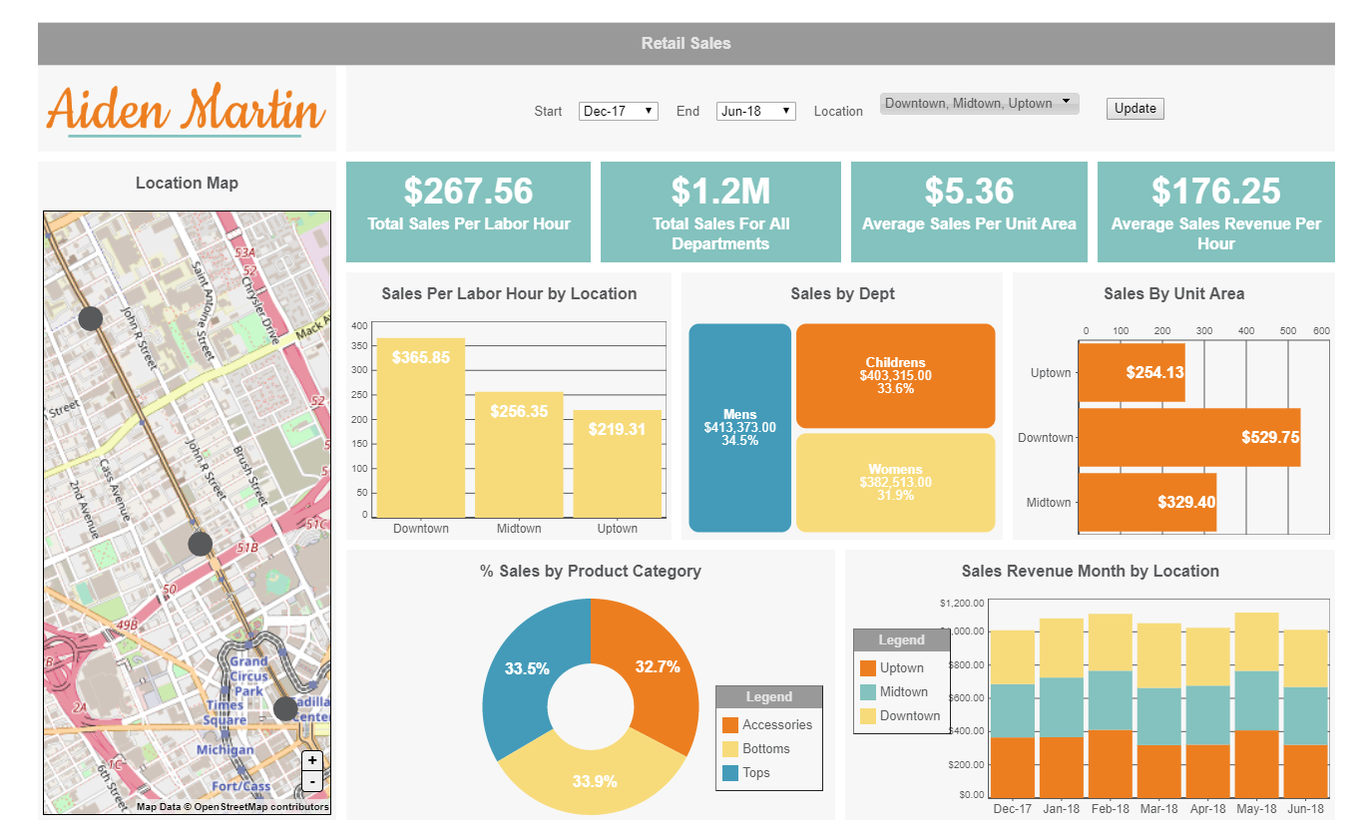

Source: The Ultimate Guide to Storyboarding (iDashboards, 2018)

**Example 2**

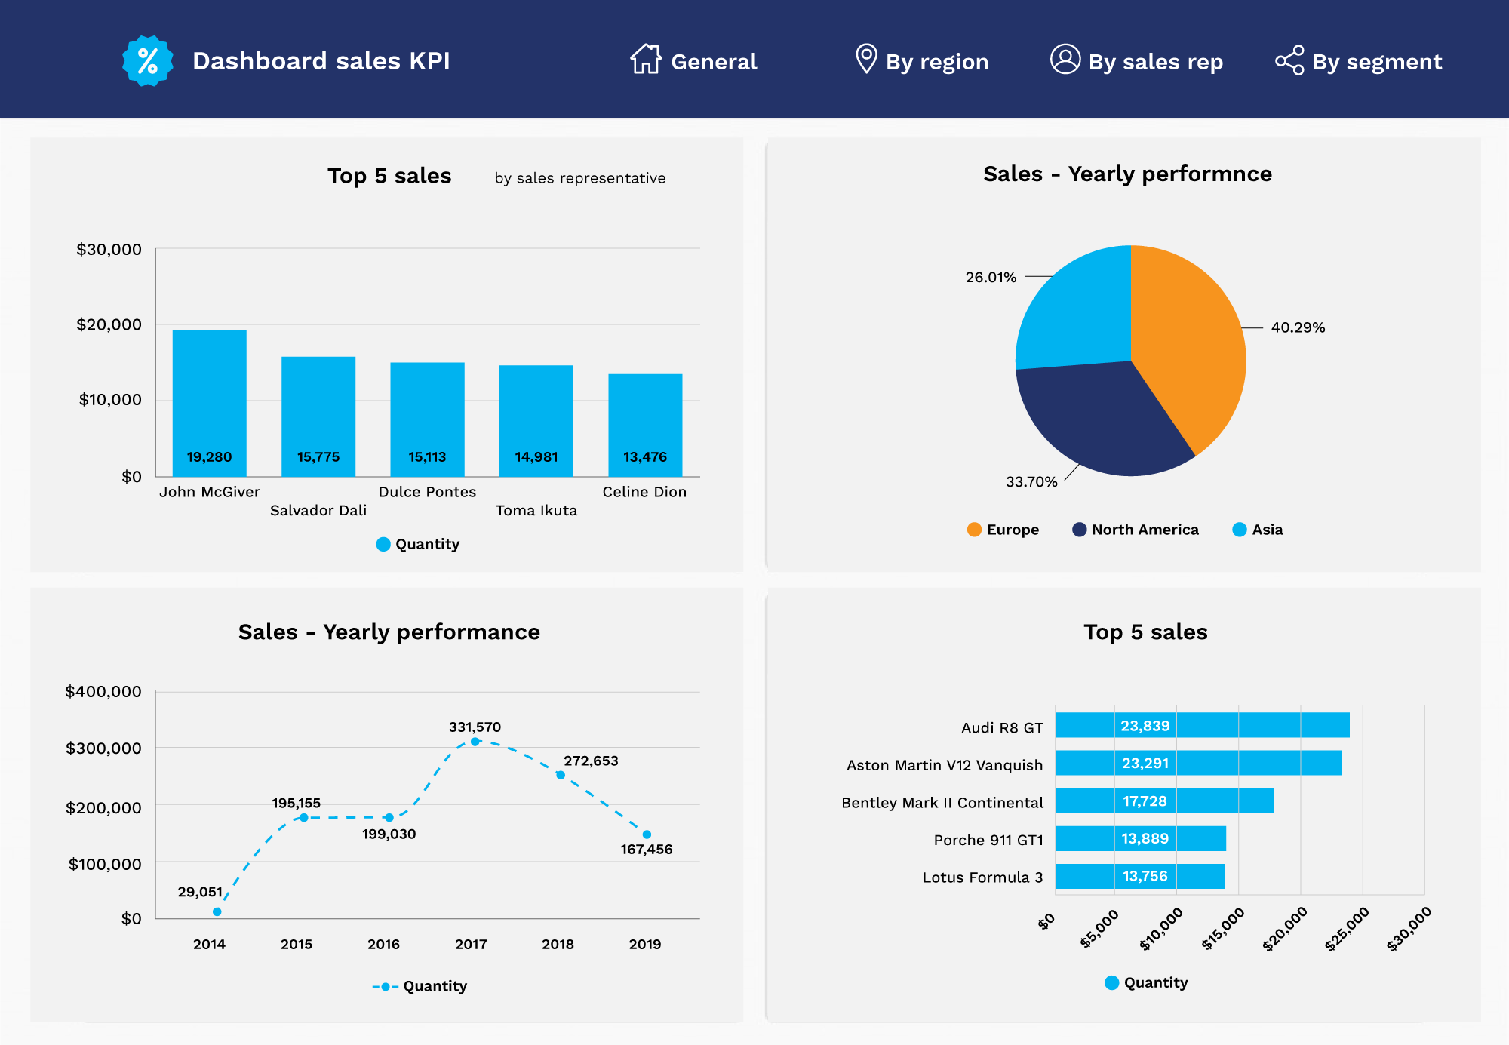

*Source: Pediatrics Center Dashboard (Fusion Charts, n.d.)*

Refer to the following article to explore 20 different examples of storyboards.

* Boicheva, A. (2021, December 22). *20 storyboard examples for different uses of storyboarding*. GraphicMama Blog. Retrieved March 3, 2022, from [https://graphicmama.com/blog/storyboard-examples/](https://graphicmama.com/blog/storyboard-examples/" \t "https://elearn.sunway.edu.my/webapps/blackboard/execute/_blank)

Refer to the following link to explore examples of dashboards.

* *Beautiful dashboards built using FusionCharts for web & mobile*. Fusion Charts. (n.d.). Retrieved March 3, 2022, from [https://www.fusioncharts.com/dashboards/](https://www.fusioncharts.com/dashboards/" \t "https://elearn.sunway.edu.my/webapps/blackboard/execute/_blank)

### 4.3.1 Examine visual displays for a case study

#### Activity: Examine visual displays for a case study

****Time****: 20 minutes

****Purpose****: To learn how to create a data visualisation storyboard.

****Task****: Read the instructions and discuss and debate the three questions below with two of your peers.

Imagine you work for a stockbroker who focuses on IPO investments, and you want to make a visualisation to help him decide where to invest. You might ask a question like, “Does profitability at IPO affect stock performance?” That might lead you to produce this view:

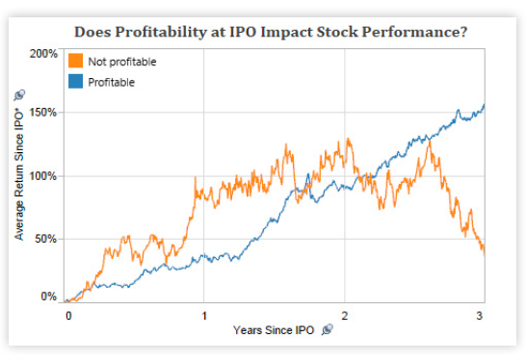

Source: Visual Analysis Best Practices, Simple Techniques for Making Every Data Visualization Useful and Beautiful (Tableau.com, n.d.)

From this view, you would discover that profitability at IPO has a huge effect on its later performance. However, this dataset contains information on all software company IPOs over the past three decades. You might wonder if the trend you have discovered holds throughout all periods. A second view could help you answer that question:

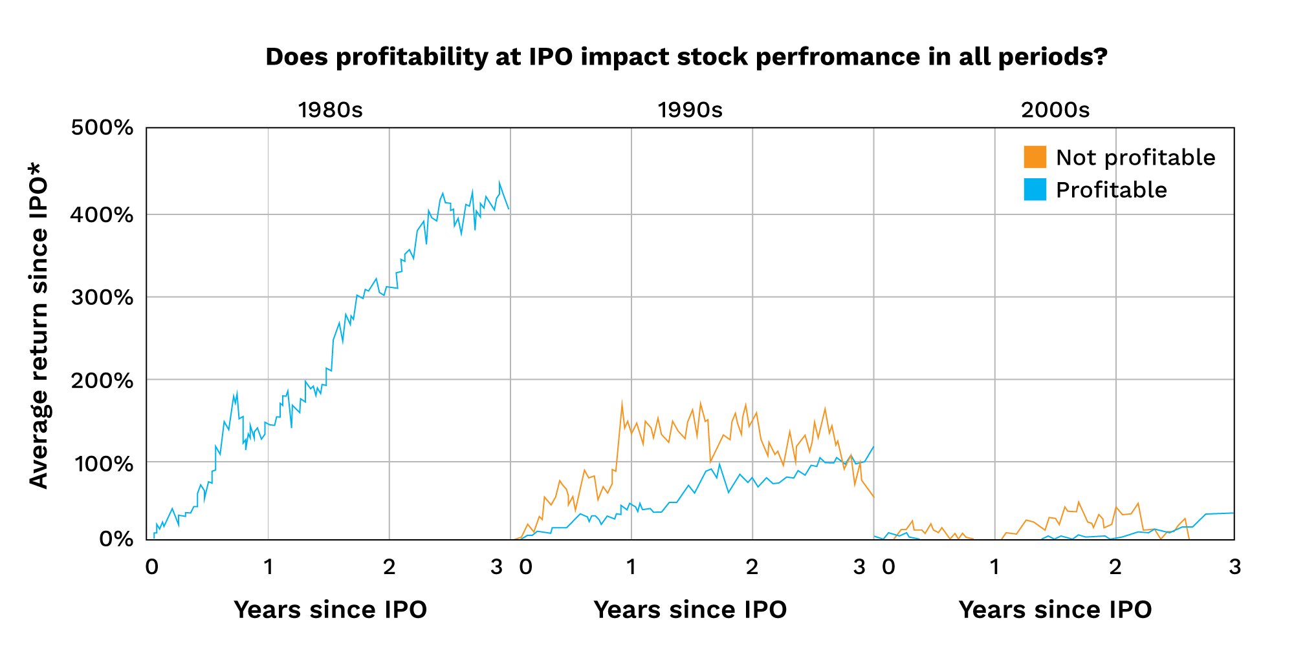

Source: Visual Analysis Best Practices, Simple Techniques for Making Every Data Visualization Useful and Beautiful (Tableau.com, n.d.)

You can see from this view that the trend only applies to the 1990s.

**Questions**

1. Based on the two views you have seen, can you make a few discoveries of your own?
2. Based on the second view, can you infer if modern investors are more risk-prone than their predecessors?
3. Do companies that were not profitable at IPO have an equal likelihood of future success as those that are profitable? Justify your answer.

### 4.3.2 Assessment aligned activity

#### Assessment aligned activity

****Time****: 40 minutes

****Purpose****: To evaluate an Interactive Tableau dashboard.

****Task****: Analyse a data visualisation and evaluate options to improve it.

****Feedback****: To help further the conversation, respond to the posts of at least 2 of your peers. You can ask them questions for clarification on their approach or provide them with feedback. Your facilitator will moderate this discussion.

**Instructions**:

1. Analyse an [executive overview](https://public.tableau.com/app/profile/mirandali/viz/SeahorceVizsSamplev8/ExecutiveOverview" \t "https://elearn.sunway.edu.my/webapps/blackboard/execute/_blank) data visualisation.
2. Individually evaluate different options to improve this visualisation. Post a brief description detailing the reasoning behind the chosen selection and where the changes are required.